Slow Down
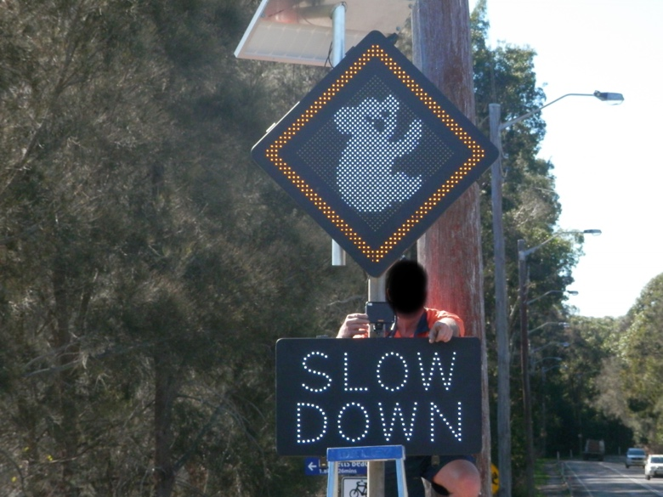
Ian Morphett Myal Koala & Environment Group | May 2016

Many locals will have already seen the new solar-powered, speed activated sign erected last week at the foot of the Singing Bridge.
The sign lights up with a koala image and the words “SLOW DOWN” when a vehicle approaches exceeding the 50 KPH speed limit.
The Myall Koala and Environment Group has been negotiating with Great Lakes Council for 18 months to get this sign installed following FOUR koala deaths from vehicle hits along the stretch of Kingfisher Avenue between the bridge and Ibis Avenue.
The Koala Group is contributing $5,000 towards the cost of this sign.

An analysis of vehicle speeds on Kingfisher Avenue in February and March 2015 found that the AVERAGE speed at the foot of the bridge was 64.8 KPH!
Many vehicles must be travelling much faster than this.
This sign has the ability to collect statistics on vehicle speeds which will enable Council to monitor the ongoing benefit of the SLOW DOWN sign.

The Koala Group pleads with drivers to PLEASE SLOW DOWN! The time saved by speeding the 500m between the bridge and Ibis Avenue, a frequent koala crossing area, would be less than a minute but the risk to our koalas is unacceptable.

