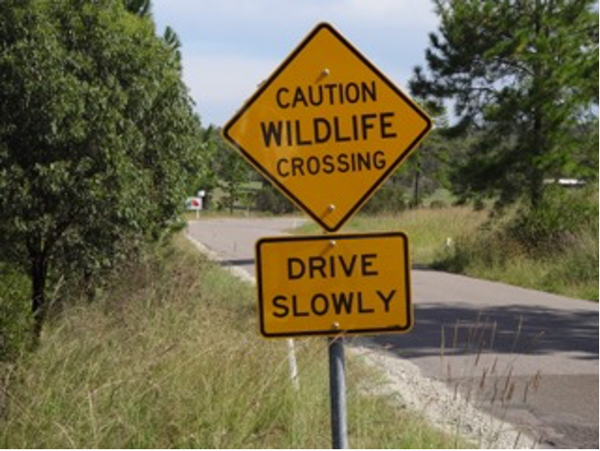
New Sign to Save Lives
Adrienne Ingram Myall Koala & Environment Group | March 2015

Wildlife on Pindimar Road outside Tea Gardens maybe a little safer, thanks to the Great Lakes Council.
Following a resident alerting them to the disappearance of a “Caution Wildlife” sign near the Myall Way junction, the GLC replaced the sign within a few weeks.
The upgraded sign, pictured, alerts drivers heading to and from Pindimar North, Pindimar South and Bundabah, to the abundance of wildlife along Pindimar Road.
Residents contacted GLC following a number of vehicle strikes killing several kangaroos.
Residents wrote that a reduction in the 100kph speed limit on Pindimar Road would also make it safer for both drivers and wildlife.

