Koalas again a hit at festival
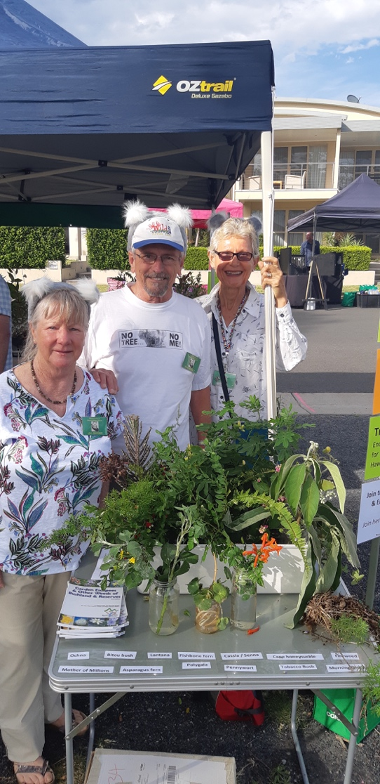
Adrienne Ingram Myall Koala & Environment GROUP October 2019
Figure 1Jill Madden, Ian Morphett, Adrienne Ingram showing noxious weeds found on the Myall Coast

Volunteers from the Myall Koala and Environment Group introduced a novel feature on their stall at this year’s Myall River Festival.

As well as the ever-popular presence of the giant Kim the Koala and giving away more than 200 koala food trees, this year the volunteers had gathered a display of some of the most noxious weeds found on the Myall Coast.

It gave them a chance to help visitors to the stall to identify weeds on their properties and to learn how deadly even some of the more attractive invasive weeds are.

The group were again surprised at how interested residents and visitors alike were in local environmental issues. Youngsters in particular were thrilled to have their photos taken with Kim the Koala.

For the fourteenth year, the Myall Koala and Environment Group gave away more than 200 free koala food trees provided by MidCoast Council.

The group’s president Jill Madden said many people came back year after year for the tree seedlings and reported on how their early plantings had now grown.

“Large parts of the Tea Gardens and Hawks Nest area are now more beautiful and koala-friendly because of our tree giveaways,” Jill said.

