Koala trees a hit at Myall River Festival
Adrienne ingram Myall Koala & Environment Group | October 2018
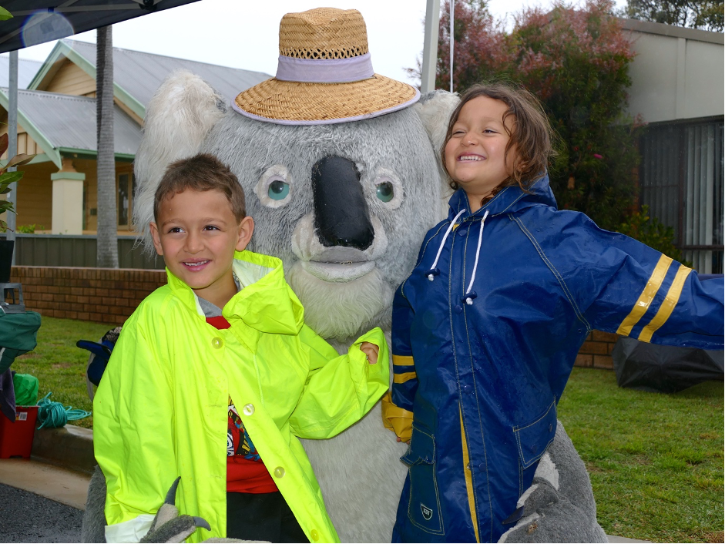
Young visitors Omar and Aya from Hornsby enjoy a cuddle with Kim the Koala.

Environment volunteers gave away 300 koala food tree seedlings at this year’s Myall River festival.
Jill Madden, president of the Myall Koala and Environment Group said the trees, which were mostly koala food species, went quicker than in previous years, demonstrating that people were taking a real interest in the survival of koalas in our region.
Several people came back to the group’s stall saying how well their trees from last year were growing.
MKEG Secretary Ian Morphett said that despite the early rain, it turned out to be a very successful day for the group. They raised more than $300 from donations, raffle tickets and merchandise sales and new membership fees. The raffle winner of two bottles of wine was a local, Diane.

