Keeping the bush clean for us all

Just hours before the latest COVID lockdown started in Tea Gardens and Hawks Nest, three local people took it on themselves to clear a mountain of rubbish near the Singing Bridge.
Many walkers, cyclists and drivers pass the area on the left-hand side of the road heading into Hawks Nest from the Singing Bridge near the koala speed sign.
Trevor Jennings wore gum boots so he could collect the rubbish on the edge of the wetlands. For an hour-and-a-half, Beth and Benny Mitchell, both Bitou Busters from Tea Gardens, joined Trevor to pickup ten shopping bags of rubbish comprising of cans, bottles, plastic, Mc Donald’s food bags and general rubbish.
Asked why she did this, Beth said she likes to do her bit as she loves this area.
Within only 300 metres, they collected more than 100 bottles and cans filling half an Otto bin, together with a dozen beer glasses suggesting this area is a regular drinking spot.
This isn’t a one-off act of community kindness, as Trevor, Beth and Benny regularly pick-up rubbish around town.
Trevor said he does this as he feels disgusted by humans who trash the roadside.

Report litter thrown or blown from a vehicle on epa.nsw.gov.au/reporttoepa

Report illegal dumping of rubbish on ridonline.epa.nsw.gov.au
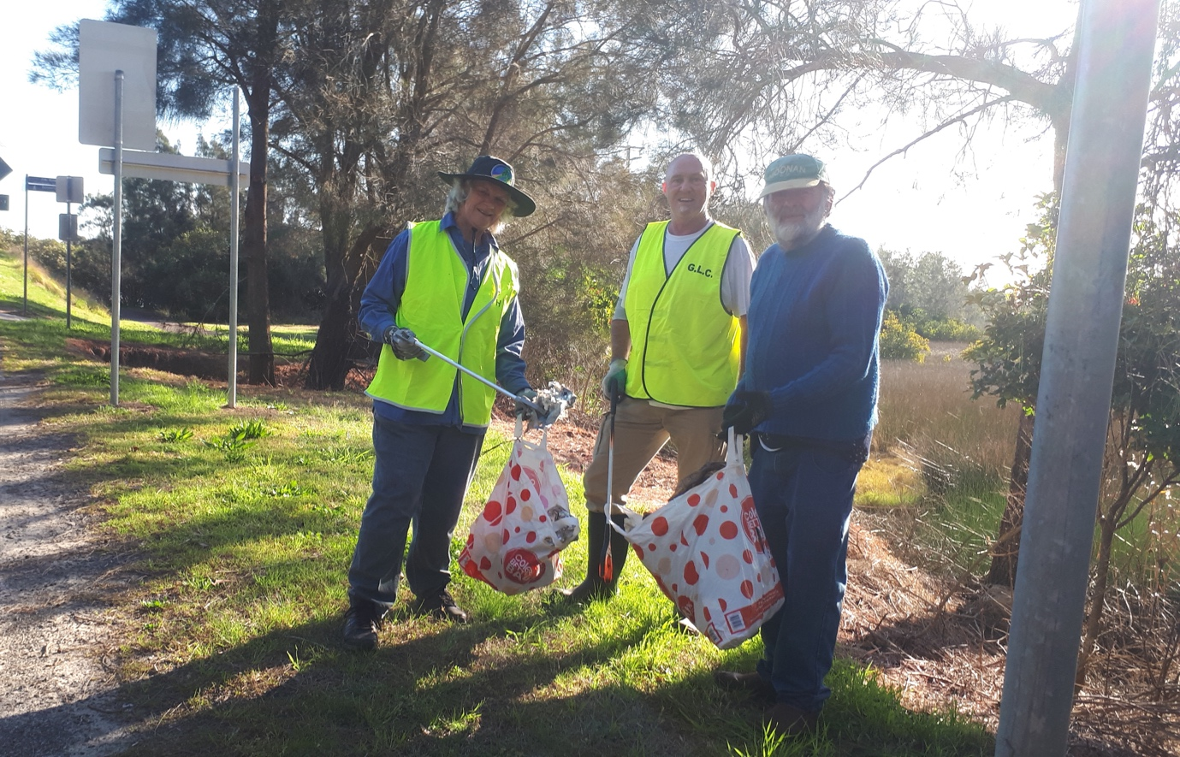

Trevor Jennings and two friends cleaning up Sanderling Avenue.

