Easter raffle raises $640
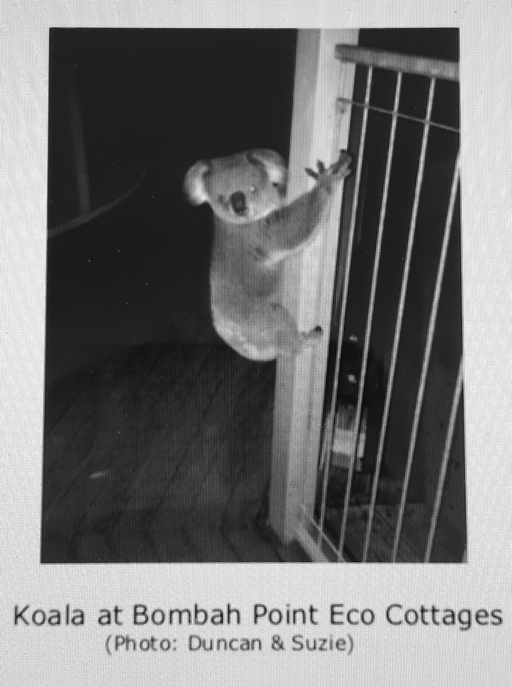
Ian Morphett Author | April 2020
,
THANK YOU, THANK YOU, THANK YOU to you, our members, who supported the raffle so enthusiastically!

Despite the Corona Virus, the raffle raised $640 of which $425 came from members via the Direct Deposit method.

These are the lucky winners from our Easter raffle:
- First Prize. Christine McMaster (Red Ticket A32), Koala Group member, chose the Koree Farm hamper.

- Second Prize. Barbara Shearer-Jones (Purple Ticket A45). She chose the painting.

- Third Prize. Philip Davidson (Blue Ticket B32). He received the wine.

