THE MYALL KOALA & ENVIRONMENT GROUP INC.
MINUTES OF THE ANNUAL GENERAL MEETING HELD ON 18h May 2021.
The meeting, chaired by President Richard Streamer, was held in the Silver Dolphin Room at the Tea Gardens Hotel and there were 12 members present. The meeting commenced at 7:35 pm.
PRESENT. Jill & Peter Madden, Kit & Richard Streamer, Ian Morphett, Trish Blair, Jane Collison, Lorraine Lock, Lyn Mealey, Ann Woods, Debbie & Colin Wood.
APOLOGIES. Christian Patteson, Gail Morphett, Kevin & Anne Haskew, Bev Dunbar & John Duffield, Vivienne Wood, Lynn & Chris Stevenson, Sandy & Charlie Shuetrim, Norm & Pamela Nolan, Roger & Cathy Humphreys, Adrienne Ingram, Di & Colin Ayers.
MINUTES:
Last year’s AGM minutes had been distributed to all members following the September AGM which was delayed due to Covid-19.
MOVED: Debbie Wood
SECONDED: Trish Blair that the minutes be taken as read. CARRIED.
PRESIDENT’S REPORT.
Richard read his report to the meeting and a copy will be distributed to all members as part of these minutes.
MOVED: Jane Collison
SECONDED: Trish Blair that the report be accepted. CARRIED.
TREASURER’S REPORT.
Trish Blair read her report to the meeting as well as outlining an overview of our financial position. A copy of her report as well as detailed financial statements will be distributed to members as part of these minutes.
MOVED: Kit Streamer
SECONDED: Lyn Mealey that the report be accepted. CARRIED.
KOALA REPORT.
Ian Morphett read the Koala Report to the meeting and a copy will be distributed to all members as part of these minutes.
MOVED: Jill Madden
SECONDED: Lyn Mealey that the report be accepted. CARRIED.
ELECTION OF OFFICERS.
Although normally, the President would stand aside to allow an independent person to conduct the elections, because all office bearers were standing for re-election unopposed, this was considered unnecessary. Because the Humphreys are leaving town, Roger Humphreys is not standing again. The Haskews have advised that they will be unable to attend meetings in the
THE MYALL KOALA & ENVIRONMENT GROUP INC.
future and so Kevin will not stand for the committee. Two members nominated as new committee members: Jane Collison and Debbie Wood. It was confirmed that our constitution does not specify a maximum number of ordinary committee members but does specify a minimum of three.
Richard declared that the following positions were elected unopposed:
President: Vice-President: Secretary:
Treasurer:
Public Officer: Publicity Officer: Koala Co-ordinators: Committee Members:
Richard Streamer Jill Madden
Ian Morphett Trish Blair
Ian Morphett
Adrienne Ingram
Glen and Lynda Stevenson
Christian Patteson, Peter Madden, Kit Streamer, Jane Collison, and Debbie Wood.
President Richard Streamer declared the meeting closed at 8:12 pm
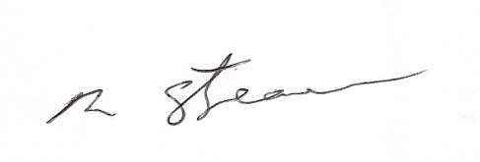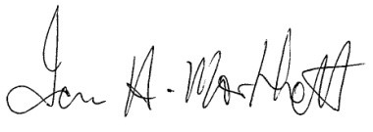
Richard Streamer President
Date: 18th May 2021
Ian Morphett Secretary
Date: 18th May 2021

