2018 Easter stall results
Ian Morphett Myall Koala & Environment Group | April 2018
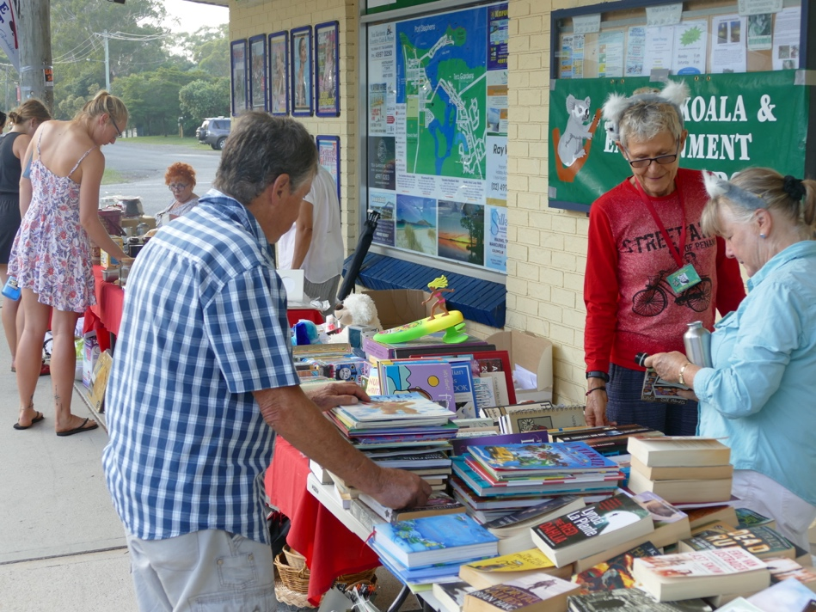
There was great weather for our Easter stall and, as usual at Easter, there were lots of people about. Our sales were EXCELLENT despite some early reservations about low visitor numbers which proved to be unfounded.

The overall result was sales of $1,787.50
Peter & Jill Madden, Adrienne Ingram

We really must thank all the helpers who put in so much effort on the day and, of course, all the goods that you, the members, donated. THANK YOU!

