THE MYALL KOALA & ENVIRONMENT GROUP INC.
Minutes of Quarterly Meeting held on 15th February 2022
The meeting, chaired by President Richard Streamer, was held in the Silver Dolphin Room at the Tea Gardens Hotel. There were 7 members present (a quorum – just). The meeting commenced at 7:40pm.
PRESENT. Jill & Peter Madden, Richard Streamer, Ian Morphett, Trish Blair, Ann Woods, Marilyn Mercer.
APOLOGIES. Christian Patteson, Gail Morphett, Bev Dunbar & John Duffield, Jane & Laurie Collison, Kit Streamer, Lyn Mealey, Dudley Mercer, Debbie & Colin Wood, Adrienne Ingram, Lynn & Chris Stevenson, Leigh Allen, Margaret Gooding.
MINUTES OF PREVIOUS MEETING.
Minutes of the November quarterly meeting had been distributed to all members following that meeting and redistributed before this meeting.
MOVED Jill Madden
SECONDED Peter Madden that the minutes be taken as read. CARRIED.
MATTERS ARISING FROM MINUTES.
• None.
CORRESPONDENCE. (Incoming and outgoing.) • Ian Morphett read the list of correspondence
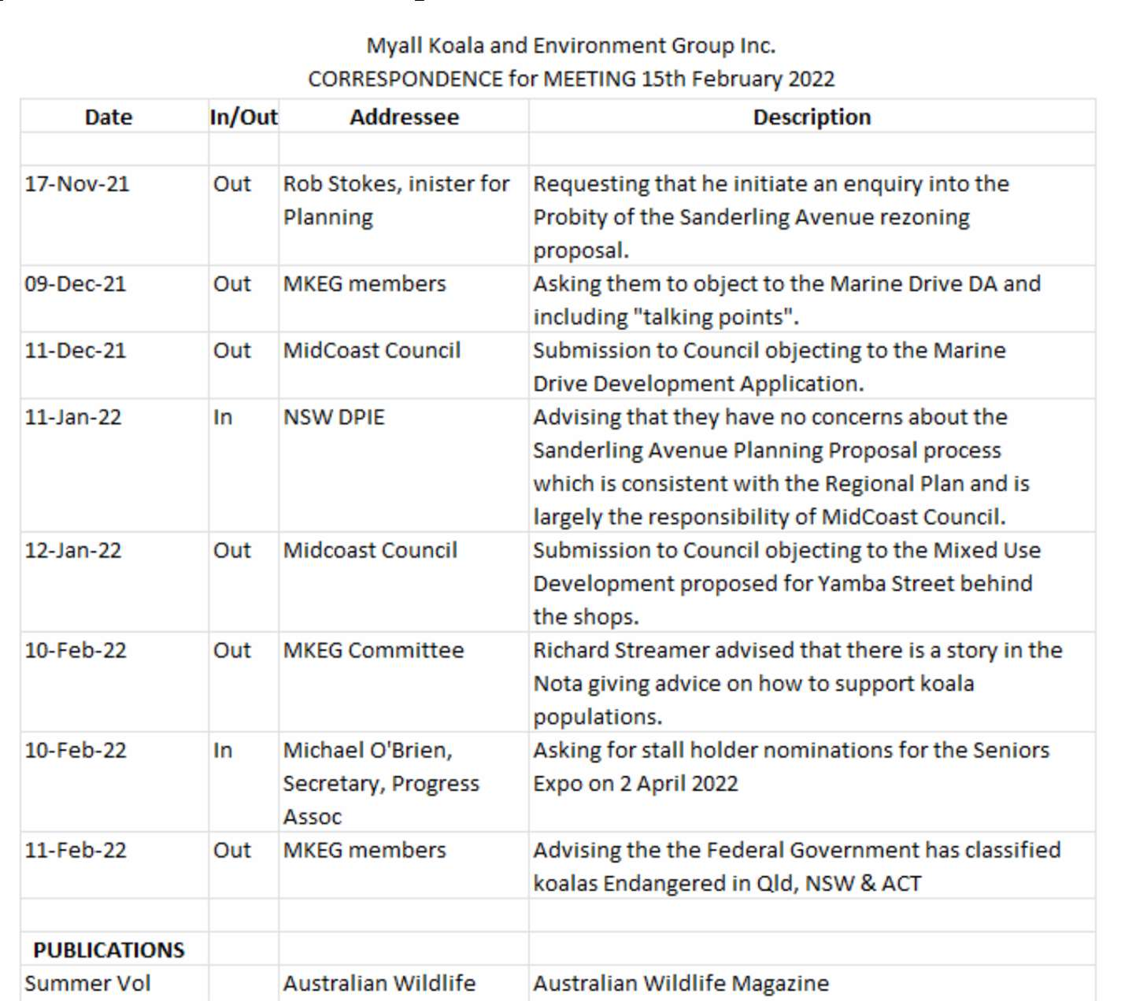
Page 1 of 6
THE MYALL KOALA & ENVIRONMENT GROUP INC.
• Ian discussed the correspondence about the request to the Minister for Planning requesting and enquiry into the Dept of Planning about their handling of the Sanderling Avenue rezoning Planning Proposal which brushed us off. As suggested, Ian followed up with a phone call to Paul Maher, Senior Planning Officer with Central Coast and Hunter Region of the Department. Again, he was given the clear message that the Department won’t be launching an enquiry because they consider the correct processes have been followed ad that it's MidCoast Council’s problem. Paul did say to mobilise the community when the DA for the site is lodged.
MOVED Trish Blair
SECONDED Richard Streamer that the correspondence be accepted. CARRIED.
TREASURER’S REPORT.
- • Trish Blair presented the Quarterly Financial Report for October to December 2021 (see below).
- • Our operating account at Regional Australia Bank closing balance as at 31st December was $8,147.67.
- • Our Bankwest investment account balance is $ 17,184.96.
- • Our total assets at 31st December 2021 is $ 25,334.78.
- • Significant outgoings in the period included website final payment $1,305 and tree guards final
payment $2,860. We received reimbursement of 50% of the tree guards cost from MidCoast Council $1,373.
MOVED Ian Morphett
SECONDED Jill Madden that the Treasurer’s report be accepted. CARRIED.
Page 2 of 6
THE MYALL KOALA & ENVIRONMENT GROUP INC.
FINANCIAL REPORT FOR MYALL KOALA AND ENVIRONMENT GROUP
1st October 2021 to 31st December 2021
A - RAB Operating Account opening balance 1/10/2 |  |  |  | 21 | 9,178.35
 | Income | Membership |  | 129.78
 |  | Donations |  | 936.40
 |  | Phone Reimbursement MCC |  | 0.00
 |  | Interest - C | PP | 734.74
 |  | Insurance |  | 0.00
 |  | Raffle |  | 0.00
 |  | Merchandise sales |  | 0.00
 |  | Cake Sales |  | 0.00
 |  | MCC tree guards 50% share |  | 1,373.00
 | Total Income from Operations |  |  |  | 3,173.92
 | Expenses | Bank Fees |  | 0.00
 |  | Phone |  | 0.00
 |  | Insurance |  | 0.00
 |  | Dept Fair Trading |  | 0.00
 |  | Affiliations | and Subscriptions | 0.00
 |  | XMAS Party Food |  | 0.00
 |  | Tubestock |  | 0.00
 |  | Tree guard plaques |  | -2860.00
 |  | PO Box |  | 0.00
 |  | Koala Survey |  | 0.00
 |  | Raffle Expenses |  | 0.00
 |  | Promotional Giveaways |  | -39.60
 |  | Web design |  | -1,305.00
 | Total Expenses from Operations |  |  |  | -4,204.60
 | Total Profit/Loss From Operations |  |  |  | -1,030.68
RAB Operating Account closing balance 31/12/2021 |  |  |  |  | 8,147.67
B - BANKWEST Investment Account opening balance |  |  |  | 1/10/2021 | 17,184.96
 | Income | Interest |  | 2.15 | 2.15
 | Total BANKWEST Profit/Loss |  |  |  | 0.00
BANKWEST Investment Account closing balance 31/12/2021 |  |  |  |  | 17,187.11
TOTAL ASSETS AS AT 31st DECEMBER 2021 |  |  |  |  | 25,334.78
0
Page 3 of 6
THE MYALL KOALA & ENVIRONMENT GROUP INC.
GALLERIES IN THE GARDENS (GIG) COOL SUMMER EXHIBITION
- • We sponsored this year’s exhibition on the theme of “Celebrating Nature of the Myall Coast”. We donated $600 prizemoney for two prizes – 2D work (painting) and 3D work (sculpture).
- • GIG donated a painting of strelitzias to us for use in our raffle.
- • Unfortunately, the exhibition opening night which usually draws a crowd of a couple of
hundred had to be limited to members of GIG and MKEG only due to Covid restrictions.
- • The winning painting was by Bev Struik and the winning sculpture was a collaborative
work by David Matheson and Gail Rust.
- • We did manage to sell some raffle tickets on the night and over the next couple of weeks in
the grounds of the Gallery.
EASTER STALL AND RAFFLE
- • The Easter stall will be held in Yamba Street outside Hawks Nest Newsagency as usual between 8am and noon on Saturday 16th April.
- • In addition to Easter Saturday, our Easter raffle will run for four weeks prior to Easter as follows:
  - • Saturday 19th March on the Tuloa Street footpath outside Hugo’s from 8am to Noon
  - • Saturday 26th March on Marine Drive Tea Gardens outside Myall River Bakery
from 8am to Noon
  - • Saturday 2nd April on the Tuloa Street footpath outside Hugo’s from 8am to Noon
  - • Saturday 9th April on the Marine Drive Tea Gardens outside Myall River Bakery
from 8am to Noon
- • The stall and raffle locations have been booked on MidCoast Council’s “Vibrant Spaces”
website.
- • Richard Streamer advised that the Myall River Bakery is OK for us to sell raffle tickets
outside their shop.
- • We have asked members to deliver their items for sale to Richard Streamer’s garage at 3
Kururma Crescent on the Wednesday or Thursday before Easter. Alternatively, they can
deliver them to the stall on Easter Saturday.
- • Goods must be clean, must work and have reasonable prospect of selling.
- • Jill Madden will handle pricing of goods which will basically be in price groupings (50c,
$1, $5, $10, etc.) except for selected items that may be more valuable and priced
individually.
- • A number of members have already offered to help sell raffle tickets and work on the stall
but we will need some more. Ian Morphett to send out reminders for more goods and helpers.
KOALA DISPLAY AT TEA GARDENS LIBRARY
- • Adrienne Ingram arranged with the librarian to set up a koala display in a glass case in the library.
- • It contained various books about koalas and photos of local koalas supplied by us and information sheets about our Group and the Hawks Nest Nature Walk.
- • We believe the display was well received by library visitors, particularly children.
- • Adrienne could have provided more detail but was unable to attend tonight’s meeting.
Page 4 of 6
THE MYALL KOALA & ENVIRONMENT GROUP INC.
HAWKS NEST NATURE WALK
- • The Nature Walk designed by Jill Madden and her helpers is now available for the public to experience.
- • Adrienne Ingram has arranged for a story in the NOTA about the walk including the QR code that will lead walkers to an online map on our webpage.
- • Council has supplied and installed a map sign of the walk on the John Davis sign at the beginning of Sanderling Avenue. Unfortunately, the sign does not have the QR code on it. Richard Streamer is organising to print, laminate and glue a QR code to the sign.
- • Adrienne has arranged for copies of the Nature Walk map to be available in Hugo’s newsagency, the two caravan parks, Benchmark, Hawks Nest Motel and TG Hotel.
RECENT DA SUBMISSIONS
- • Ian Morphet advised that two submissions opposing Development Applications have been lodged since the last meeting.
- • A submission about the ludicrous 5 storey apartment building on the land adjacent to the pub was lodged. Ian believes that it has to be an ambit claim for more than the developer hopes to get approval for in anticipation of negotiating something less (perhaps remove one floor). The reduced footprint they are aiming for will inevitably still be well above the standard building codes.
- • A submission was lodged opposing the “Shop Top” apartment proposal for Yamba Street on the land behind the existing shops. It only includes 2 shops but takes up space for 6 shops. It pushes for 4 floors and includes ugly facades facing Tuloa Avenue and the Council car park. The access to the car parking is via the narrow laneway off Tuloa Avenue to the south which is already congested. Ian read a passage from the submission describing how the community is opposed to overdevelopment proposed by this and other applications in Hawks Nest and Tea Gardens.
LITTLE TERNS AND PIED OYSTER-CATCHER BREEDING PROGRESS
  - • Trish Blair gave a brief report about this summer’s unsuccessful Little Tern breeding season but has written a comprehensive report which will be separately sent to members.
  - • It was reported that someone had torn one of the shore bird information signs off its stake and used it as a sled on the slope of the sand stockpile.
  - • Ann Woods reported that “Beaky”, the pied oystercatcher with the deformed beak, is still surviving but is on his own. She has a video of him feeding. She offered the video to any members interested.
  - • The Shorebird monitoring team intend to apply for a Saving Our Species grant to provide for additional resources to support next year’s program.
PROGRESS ASSOCIATION SENIORS EXPO
  - • The HN/TG Progress Assoc. is running a “Seniors EXPO” in the Hawks Nest Community Hall on Saturday 2nd April. They have obtained a grant to cover the costs of the EXPO.
  - • Community groups have been asked if they would like a table, a shared table or a display stand to showcase their activities to the community. Because of the grant, there will be no cost to community groups.
  - • We decided that we will participate with a full table. We may be able to use this event to help sell our Easter raffle tickets instead of outside Hugo’s. Richard Streamer will confirm our participation with Sandra Bourke (the PA event co-ordinator) and ask her if it’s OK for us to sell raffle tickets.
Page 5 of 6
THE MYALL KOALA & ENVIRONMENT GROUP INC.
ADDITIONAL TREE GIVEAWAY AND PLANTING
- • The Midcoast Council plant nursery has an excess of Parramattensis tube stock that they need to get rid of.
- • Jill Madden has agreed to take 100 of them plus some native plants.
- • We decided to give them away at the Providore Market on Saturday 26th February.
- • Jill will supervise planting of some of the better remaining trees after the giveaway in
selected locations in town.
- • Christian Patteson has agreed to re-pot any remaining trees for next spring.
DECLARATION OF KOALAS AS ENDANGERED
- • The Commonwealth has announced that koalas in Queensland, NSW and ACT have been declared “ENDANGERED” in response to the Threatened Species Scientific Committee’s recommendation.
- • This follows the recent announcement that the Commonwealth is allocating $50 million for koala protection actions.
- • Hopefully, these actions will act over time to reduce the koala population decline and prevent their extinction by 2050. Government aims are to DOUBLE the population by 2050.
GENERAL BUSINESS
- • Richard Streamer reminded members that the next meeting in May is our AGM where office bearers and Committee members will be elected. He expressed concern that current committee members Lynda and Glen Stevenson are leaving town and Jill Madden is standing down as Vice President because she and Peter (also a Committee Member) will be spending more time in Coledale and so will not be able to be as active as in the past. He asked members to consider standing for the Committee at the AGM. The current Committee has functioned very well over the past year, but we will need to replace those leaving.
- • Jill Madden suggested that we might like to start future meetings with an acknowledgement to country. She suggested appropriate words similar to “I would like to acknowledge that this meeting is being held on the traditional lands of the Worimi people and pay my respects to elders past, present and future”. It was agreed to.
Meeting concluded at 9:02pm.
Next meeting (the Annual General Meeting) will be held on Tuesday 17th May 2022 at 7.30pm in the Silver Dolphin Room in the Tea Gardens Hotel.
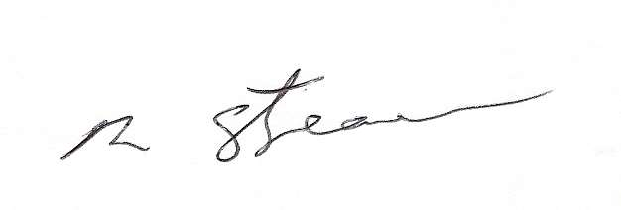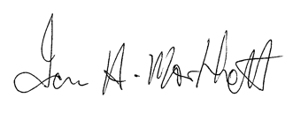
Richard Streamer President
Date: 15th February 2022
Ian Morphett
Secretary
Date: 15th February 2022
Page 6 of 6

