MINUTES OF THE ANNUAL GENERAL MEETING HELD ON 16th May 2023.

The meeting, chaired by President Richard Streamer, was held in the Silver Dolphin Room at the Tea Gardens Hotel and there were 10 members present. The meeting commenced at 7:38 pm.

PRESENT. Kit & Richard Streamer, Ian Morphett, Trish Blair, Jane Collison, Ann Woods, Debbie Wood, Christian Patteson, Judy & Rob Hughes.

APOLOGIES. Gail Morphett, Adrienne Ingram, Lyn Mealey, Leigh Allen, Christine McMaster, Laure Collison, Colin Wood, Colleen & Rob MacSween, Diane Russell.

ACKNOWLEDGEMENT OF COUNTRY:
Richard Streamer delivered the following: I would like to acknowledge that this meeting is being held on the traditional lands of the Worimi people and pay my respects to elders past, present and future.

MINUTES:
Last year’s AGM minutes had been distributed to all members prior to the meeting.

MOVED: Jane Collison
SECONDED: Debbie Wood that the minutes be taken as read.
CARRIED.

PRESIDENT’S REPORT.
Richard read his report to the meeting and a copy will be distributed to all members as part of these minutes.

MOVED: Ian Morphett
SECONDED: Trish Blair that the report be accepted.
CARRIED.

TREASURER’S REPORT.
Trish Blair read her report to the meeting as well as outlining an overview of our financial position. A copy of her report as well as detailed financial statements will be distributed to members as part of these minutes.

MOVED: Kit Streamer
SECONDED: Christian Patteson that the report be accepted.
CARRIED.

KOALA REPORT.
Ian Morphett read his final Koala Report. A copy will be distributed to all members as part of these minutes.

MOVED: Jane Collison
SECONDED: Debbie Wood that the report be accepted.
CARRIED.

ELECTION OF OFFICERS.
Ian Morphett had indicated prior to the meeting that he wouldn’t be standing as Secretary but would stand as Vice President. Judy Hughes had agreed to nominate as Secretary. The President announced the names and positions for which nominations have been received: President – Richard Streamer, Vice President – Ian Morphett, Treasurer – Trish Blair, Secretary – Judy Hughes, Publicity Officer – Adrienne Ingram, Public Officer Richard Streamer, Committee Members – Kit Streamer, Christian Patteson, Jill & Peter Madden, Jane Collison, Debbie Wood & Rob Hughes.

There being no further nominations, the following positions were declared elected unopposed.
President: Richard Streamer
Vice-President : Ian Morphett
Secretary: Judy Hughes
Treasurer: Trish Blair
Public Officer: Richard Streamer
Publicity Officer: Adrienne Ingram
Koala Co-ordinators: Vacant
Committee Members: Christian Patteson, Jill & Peter Madden, Kit Streamer, Jane Collison, Debbie Wood, Rob Hughes.

President Richard Streamer declared the meeting closed at 8:05 pm

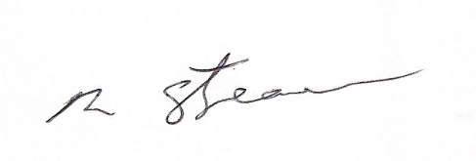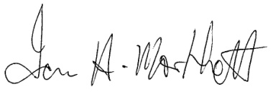
Richard Streamer Ian Morphett
President Secretary (retired)
Date: 16th May 2023 Date: 16th May 2023

