Ken the koala was the star again at festival
Ian Morphett Myall Koala & Environment Group | October 2017
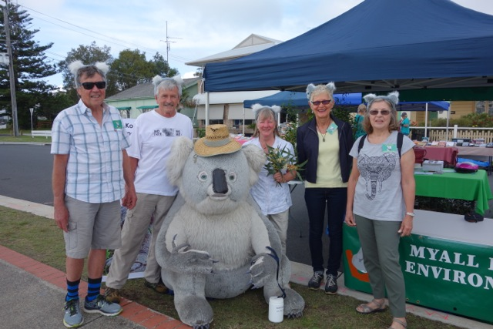
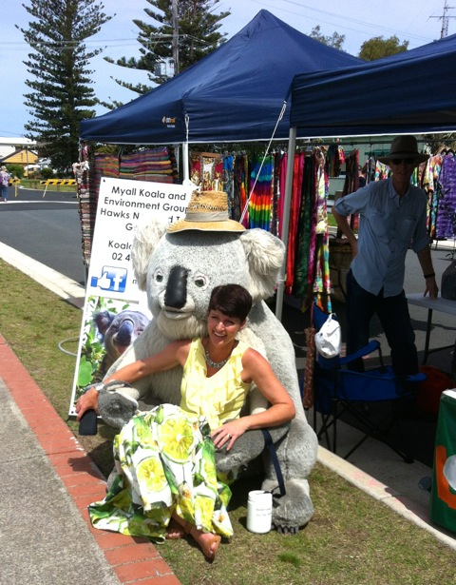
1Peter Madden, Ian Morphett, Jill Madden, Adrienne Ingram, Gwenda Collins
Kate Washington MP

We had a very successful day yesterday at the Festival. The weather was
fantastic and we even had a cooling nor'easter kick in after lunch.
We had a visit from our local State member Kate Washington who couldn't
resist getting her photo taken with Kim, our big koala.
We gave away everything we had, got SIX new members, including one who may
be our new Treasurer and another who is an environmental lawyer who offered
to do any of our legal work and make submissions for us. As usual, we got
heaps of koala sightings and handed out our cards that advertise the koala
sightings hotline (4997 0878).
I know you will all be dying to know how the donations and raffle went:
• Donations $382.75
• Raffle $218
• Our raffle winners were Bea Watkins (wine) and Raelene Partridge
(koala backpack)
Our Parramattensis trees cost us $450 so $600+ more than covers our costs.
Our thanks must go to all the helpers on the day - Jill & Peter Madden,
Adrienne & David Ingram, Gwenda Collins, Leigh Allen, Gaye McKay, Robyn
Goswell and Ian Morphett who made the day such a wonderful success.

