Wild weather welcomes volunteers

Torrential downpours did not discourage volunteers from the north of Great Lakes who came to work on dunes in Hawks Nest.

For the second year, members of Dune Care from Tuncurry, One Mile Beach Forster, Boomerang Beach and Green Point travelled by coach to help Bennetts Beach Dune Care and Hawks Nest & Tea Gardens Bitou Busters to work on the dunes near the Surf Club on Bennetts Beach.

In driving rain, the 34 volunteers and council staff planted 1,100 native plants to help stabilise the dunes against erosion, provide a more attractive view across the sands to the sea, attract native small birds and trap litter.

The visitors were met on arrival at the Surf Club car park on Friday 8 July and got to know their hosts over an early morning tea with a selection of homemade cakes they brought with them. With great excitement, everyone was entranced by 20 dolphins in two pods swimming back and forth off the beach.

Mid Coast Council’s Steve Howard organised the joint working day and provided the plants, which included Matt Rush (Lomandra longifolia), Tie Bush (Wikstroemia indica), Coast Rosemary (Westringia), Flax Lily (Dianella), Coastal Wattle (Acacia longifolia).

After planting inbetween rain showers, the volunteers boarded the bus for a sightseeing tour around Hawks Nest while Drew Morris, Natural Assets Officer, spoke about the local environment. The tour visited Winda Woppa and Jimmy’s Beach to see the sand erosion.

The volunteers returned to the dunes in the pouring rain to find Steve had moved the BBQ lunch with salads and cakes inside the Surf Club, where new friendships were formed.

Michael Richie of Bennett's Beach Dune Care thanked everyone for their great work and hoped in the near future they would be invited up to Forster Tuncurry to work on one of their dune care projects.

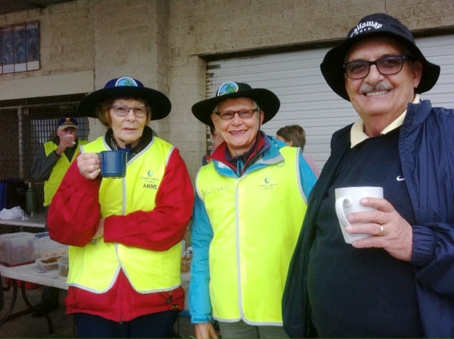
Anne Haskew, Adrienne Ingram-Bitou Busters and Michael Richie-Dune Care

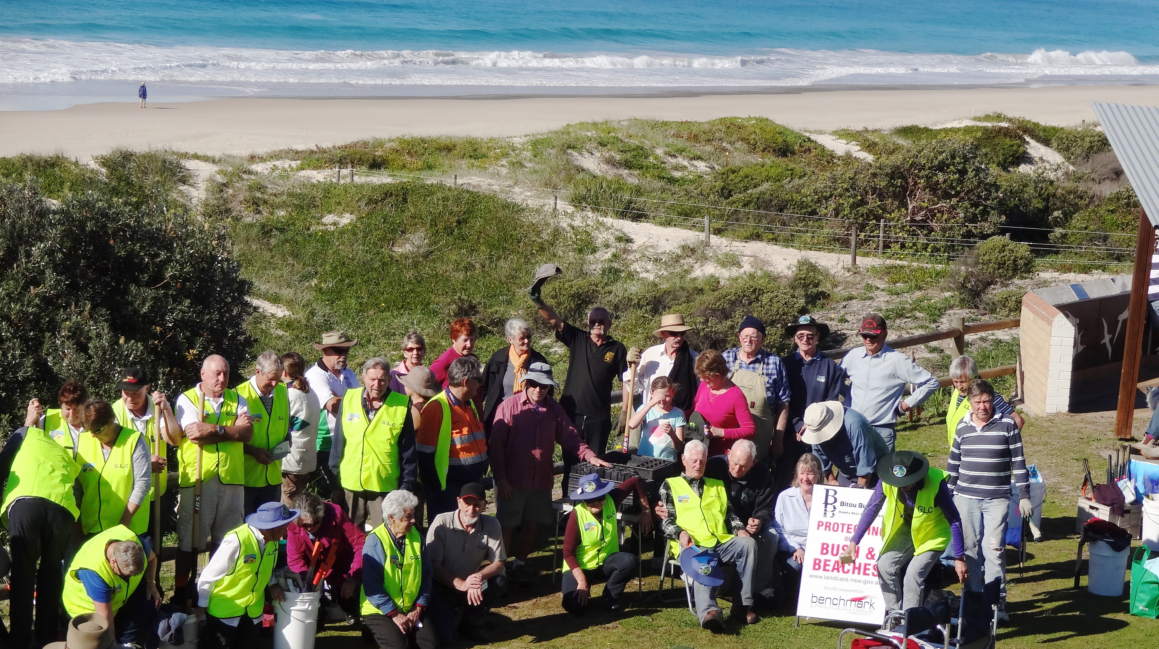

Members of Dune Care from Tuncurry, One Mile Beach Forster, Boomerang Beach, Green Point and Bitou Busters

