Annual Koala Report – May 2021
Myall Koala & Environment Group Koala Sightings Continue to Decline
To be consistent with previous years, the sighting statistics are to the end of April. This year the number of koala sightings reported to us on our hotline, face-to-face or on Facebook has dropped dramatically from 61 down to only 7 in JUST ONE YEAR. The long-term trend is all too obvious.
We are at a loss to understand with any certainty, the cause of this drop in koala sightings. Some of it may be because of a societal shift from using our phone answering machine to report sightings to online usage such as facebook. Another cause will be the 20% drop in trees in Hawks Nest a few years ago as a result of the introduction of the RFS 10/50 Rule with initial poor definition of fire threatened areas in the town. Ever increasing development has a negative impact on available koala habitat. Other causes could include attacks by domestic and feral dogs as well as dingoes. And finally, in an urban area, the effect of vehicle traffic cannot be excluded. Hopefully, our resident koalas have largely migrated to the Myall Lakes National Park to the north.
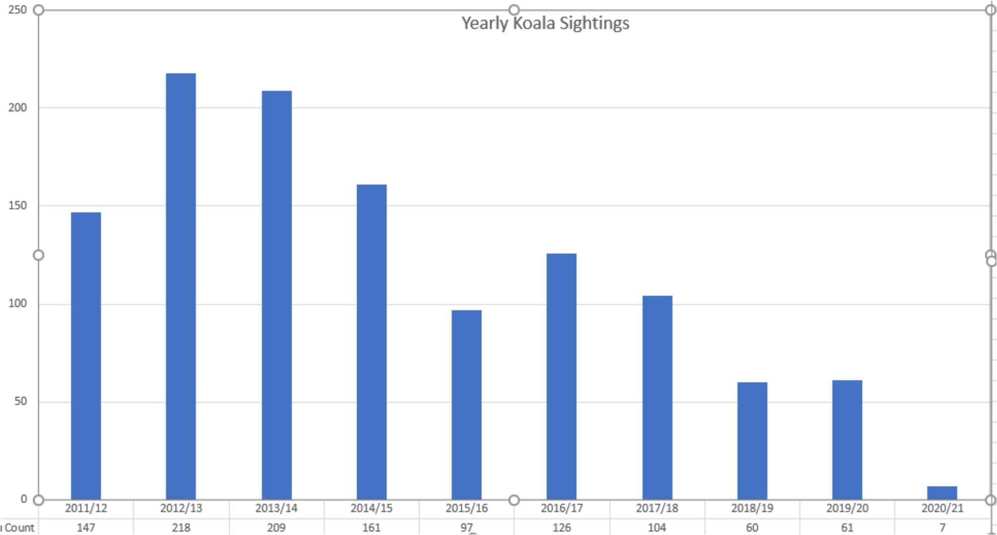
Development Proposals
Four issues relating to residential development in our area may affect our koalas:
1. Midcoast Council Housing Strategy: Council’s draft plan proposed zoning the “Magic Square” area of Hawks Nest as General Residential Zone. We have objected to this on the grounds that it would increase housing density which would result in loss of trees and consequently koalas. Sadly, Council has rejected our submission and at its meeting in December 2020 continued to propose General Residential zoning for this area.
- A Development Application for a 4 storey apartment building in Yamba Street, Hawks Nest: This DA was rejected by Council but the developer applied to the Land and Environment Court for a mediation which failed. The developer then elected to appeal the rejection to the Court in May this year but then withdrew to submit revised plans. We have yet to see what the revisions will entail.
- A Development Application for a “caravan park” retirement village on Mungo Brush Road, North Hawks Nest: We have objected to this because it includes hundreds of “manufactured homes” in the middle of the wildlife corridor between the Hawks Nest township and the Myall Lakes National Park. Despite being lodged in January 2020, the DA has not been resolved with Council’s only statement on the matter being “Further Information Requested”.
- A Planning Proposal for medium density rezoning for land adjoining the eastern boundary of Hawks Nest Golf Club: The Koala Group and many of our members lodged objections to the rezoning because the suggested 4 story buildings are inappropriate in this locality and would create an unacceptable precedent. Despite there being 65 objections to the proposal and only 9 in favour, Council approved the rezoning and said any inappropriate development could be managed when Development Applications are assessed. Again, we will have to wait to see what eventuates.
Koala Sightings Hotline
PLEASE everyone, we still want to receive your koala sighting reports on our Hotline answering machine at 4997 0878.
Gail & Ian Morphett (0410 536 556)
