THE MYALL KOALA & ENVIRONMENT GROUP INC.
MINUTES OF THE ANNUAL GENERAL MEETING HELD ON 17th May 2022.
The meeting, chaired by President Richard Streamer, was held in the Silver Dolphin Room at the Tea Gardens Hotel and there were 17 members present. The meeting commenced at 7:33 pm.
PRESENT. Jill & Peter Madden, Kit & Richard Streamer, Ian Morphett, Trish Blair, Jane Collison, Lyn Mealey, Ann Woods, Debbie & Colin Wood, Marilyn & Dudley Mercer, Christian Patteson, Judy & Rob Hughes, Adrienne Ingram.
APOLOGIES. Gail Morphett, Bev Dunbar & John Duffield, Lynn & Chris Stevenson, Di & Colin Ayers, Leigh Allen, Christine McMaster, Kevin & Robyn Green, Colleen & Rob MacSween, Laurie Collison.
ACKNOWLEDGEMENT OF COUNTRY:
Richard Streamer delivered the following: I would like to acknowledge that this meeting is being held on the traditional lands of the Worimi people and pay my respects to elders past, present and future.
MINUTES:
Last year’s AGM minutes had been distributed to all members prior to the meeting.
MOVED: Jane Collison
SECONDED: Debbie Wood that the minutes be taken as read. CARRIED.
PRESIDENT’S REPORT.
Richard read his report to the meeting and a copy will be distributed to all members as part of these minutes.
MOVED: Jill Madden
SECONDED: Trish Blair that the report be accepted. CARRIED.
TREASURER’S REPORT.
Trish Blair read her report to the meeting as well as outlining an overview of our financial position. A copy of her report as well as detailed financial statements will be distributed to members as part of these minutes.
MOVED: Kit Streamer
SECONDED: Lyn Mealey that the report be accepted. CARRIED.
KOALA REPORT.
Instead of a Koala Report, Ian Morphett read a history of Princess, potentially our last koala in town, who is currently in Port Stephens Koala Hospital. A copy will be distributed to all members as part of these minutes.
MOVED: Jill Madden
SECONDED: Peter Madden that the report be accepted. CARRIED.
THE MYALL KOALA & ENVIRONMENT GROUP INC.
ELECTION OF OFFICERS.
The President announced the names and positions for which formal, written nominations have been received: President – Richard Streamer, Treasurer – Trish Blair, Secretary – Ian Morphett, Committee Member – Kit Streamer.
Jill Madden had indicated she would not stand for Vice President because she and Peter are moving to the south coast. They will retain a house here and are prepared to stand on the Committee. Nobody has indicated a willingness to stand for Vice President.
Glen and Lynda Stevenson are moving to Darwin and so are not able to continue as Koala Co- ordinators. Nobody has indicated a willingness to stand as Koala Co-ordinators or rescuers. The Secretary is to write to members asking if anyone would like to train up to become a wildlife rescuer.
Rob & Judy Hughes agreed to be on the Committee. Adrienne Ingram agreed to continue as Publicity Officer.
Jane Collison, Christian Patteson, Debbie & Colin Wood agreed to continue as Committee Members.
Richard declared that the following positions elected:
President: Vice-President: Secretary:
Treasurer:
Public Officer: Publicity Officer: Koala Co-ordinators: Committee Members:
Richard Streamer Vacant
Ian Morphett Trish Blair
Ian Morphett
Adrienne Ingram
Vacant
Christian Patteson, Jill & Peter Madden, Kit Streamer, Jane Collison, Colin & Debbie Wood, Rob & Judy Hughes.
President Richard Streamer declared the meeting closed at 8:27 pm
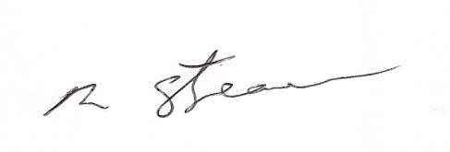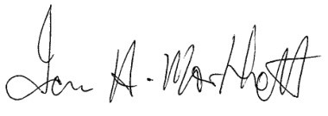
Richard Streamer President
Date: 17th May 2022
Ian Morphett Secretary
Date: 17th May 2022

