A great festival for the koala group
Ian Morphett Myall Koala & Environment Group | October 2016
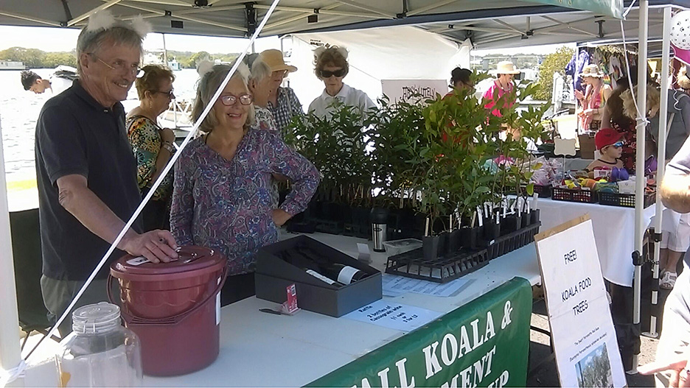
The crowd in the morning particularly, was fantastic. We had lots of good discussions about koalas and koala food trees and plants in general.
Virtually everyone who took a Parramattensis koala food tree, or a native plant made a donation or bought raffle tickets, or BOTH.
We would like to thank them all for their help in saving our local endangered koala population.
By the end of the day, we had given away everything. That’s right, there was nothing left! This was just what we had hoped for.

